Sorting Algorithms | 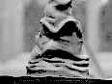

Sorting Vocabulary

stable A sort is stable if two elements of equal rank will be in their original order after the sort. For example, suppose that we have a list of names in which Joe Jones is before Sue Jones. A stable sort of the names based on last name will guarantee that Joe will still precede Sue. A non-stable sort allows for the possibility that Sue will precede Joe at the end of the sort.

in-place – little extra space is required

adaptive – number of comparisons may depend on the data's original order.

Algorithm | speed | stable | in-place | adaptive | distinction
easy sort | 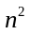 | no | yes | no | easy to code
selection sort |  | no | yes | no | best if swaps are expensive
bubble sort |  | yes | yes | no | simple and stable
shaker sort |  | yes | yes | yes | an improved bubble sort
insertion sort |  | yes | yes | yes | best for nearly sorted data
heapsort | 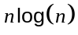 | no | yes |  | guaranteed fast in-place
mergesort |  | yes | no |  | only fast stable
quicksort | usually | no | yes |  | fastest on average
A Comparison of Sorts

Notes

- The pseudo-code for the various sorting algorithms omits type declarations and uses indentation for nesting. Provide your own types and braces.
- Make your functions generic by using templates. Which form is more general?

template <typename T>  void sortname(vector<T>& v)  {  } | template <typename T>  void sortname(T& v)  {  }

- Suppose that we have an algorithm that takes one second to run on input of size 1000. Compare the running time of the algorithm on input of size 1,000,000 in the two cases of andspeeds.
Easy Sort
Easy sort is the simplest sort to code.

easy_sort(vector& v)
for(left = 0; left < v.size(); left++)
for(right = left + 1; right < v.size(); right++)
if( v[left] > v[right] )
swap( v[left], v[right] );

Easy Sort  easiest to code  slow to run  non-stable  in-place | 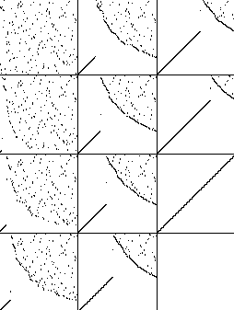 | 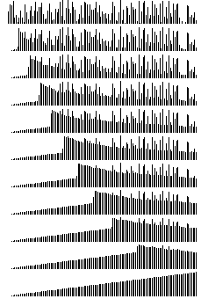

Exercises
- Implement the easy sort algorithm as a generic function easy_sort().
- Implement a function easy_shuffle() as follows. Given a vector v to be shuffled, construct a v-sized vector w of random integers, then sort w, making the same swaps in v. As w is sorted, v is shuffled.
- Give an example to show that easy sort is not stable and explain your example.
- Looking at the “dot diagram” above, we see that easy sort places the first p% of the data in its correctly sorted position after running p% to completion. The remaining unsorted portion of the data has some structure, namely a highly reversed-sorted component indicated by the downward-sloping curve. Explain. Hint: why would a large element be more likely than a small element to end up at the beginning of the unsorted portion?
- Fill in the following chart for the number of operations given n elements to be sorted. Conduct experiments on different size inputs to estimate the number of swaps in the average case.

 | best case | worst case | random data | already sorted | reversed initially
# comparisons |  | 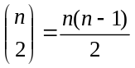
# swaps |  | 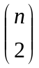

Selection Sort
Selection sort uses the fewest number of swaps and therefore is preferred for sorting large records.

selection_sort(vector& v)
for(left = 0; left < v.size(); left++)
min_index = left;
for(right = left + 1; right < v.size(); right++)
if( v[min_index] > v[right] )
min_index = right;
swap( v[left], v[min_index] );

Selection Sort  easy to code  fewest swaps  slow to run  non-stable  in-place | 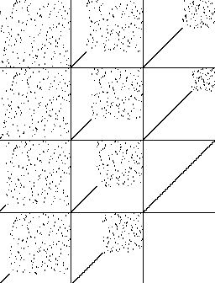 | 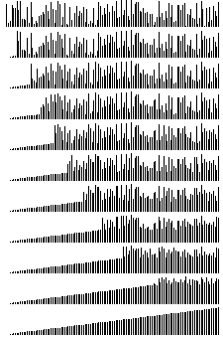

Exercises
- Implement the selection sort algorithm as a generic function selection_sort().
- Modify selection sort so that it never swaps elements having the same value.
- Explain how easy sort and selection sort are similar and how they are different?
- With easy sort, the dot diagrams showed a downward-sloping structure in the unsorted region, which is not the case with selection sort. Why?
- Give an example to show that selection sort is not stable and explain your example.
- Carefully explain why selection sort is non-adaptive.
- This exercise will prepare you for bubble sort. Modify selection sort so that its inner loop searches for the least value by passing from the end of the vector to the beginning. (The outer loop is still from beginning to end and the goal is still to sort from lowest to highest.)
- Fill in the following chart for the number of operations given n elements to be sorted. Conduct experiments on different size inputs to estimate the number of assignments in the average case.

 | best case | worst case | average case | already sorted | reversed initially
# comparisons |  | 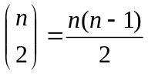
# swaps |  | 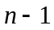

Bubble Sort
Bubble sort is a stable version of selection sort.

bubble_sort(vector& v)
for(left = 0; left < v.size(); left++)
for(right = v.size() - 1; right > left; right--)
if( v[right - 1] > v[right] )
swap( v[right - 1], v[right] );

Bubble Sort  easy to code  slow to run  stable  in-place | 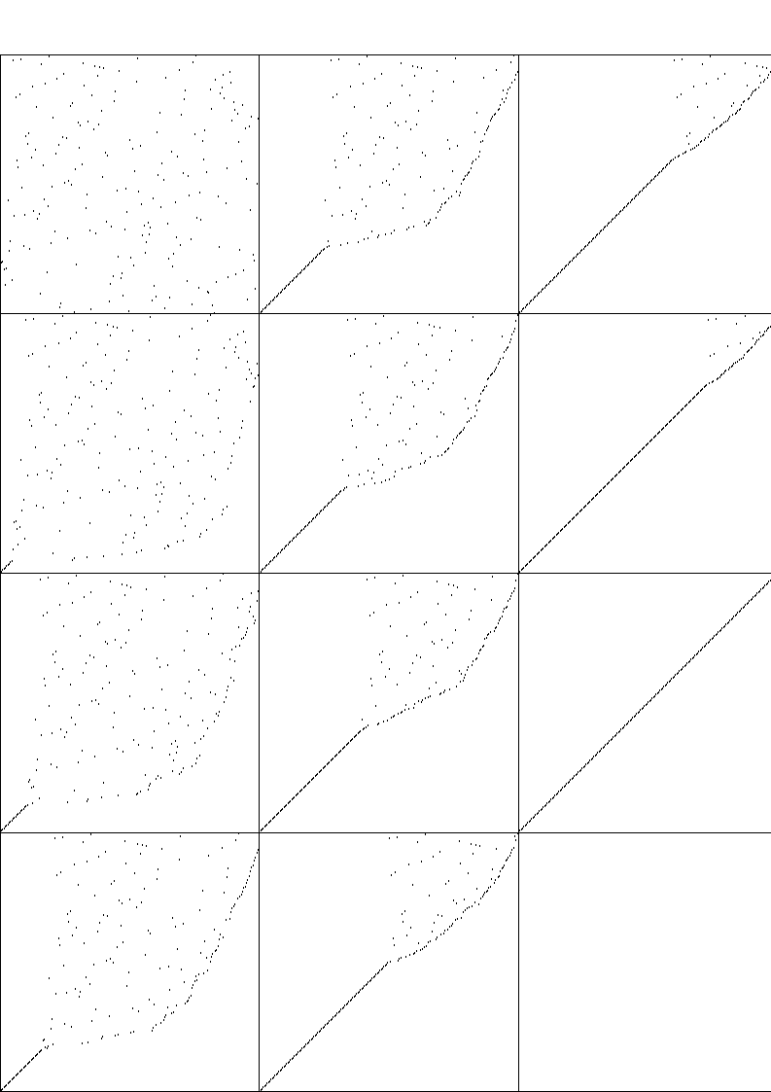 | 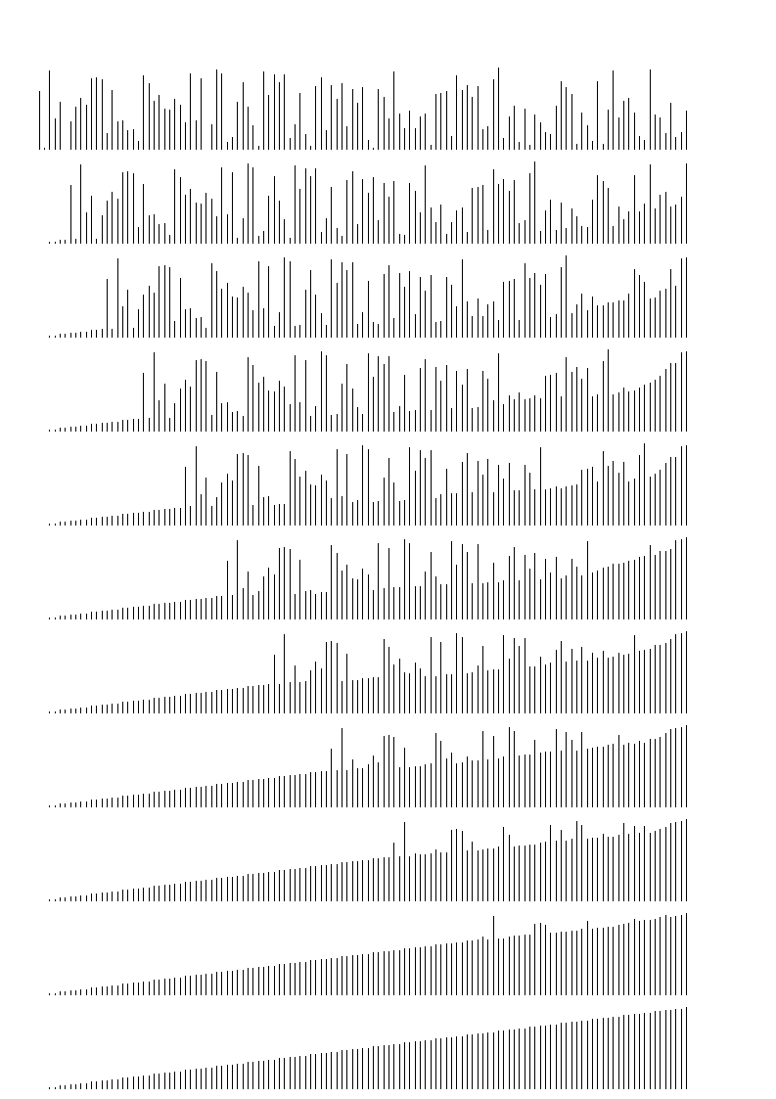

Exercises
- Implement the bubble sort algorithm as a generic function bubble_sort().
- In what way is bubble sort less efficient than selection sort?
- Argue that bubble sort is stable.

Adaptive Bubble Sort
We can modify bubble sort so that if no swaps are performed on one of the inner passes, meaning that the file is in sorted order, then the sort breaks out of the outer loop.

adaptive_bubble_sort(vector& v)
for(left = 0; left < v.size(); left++)
no_swap = true;
for(right = v.size() - 1; right > left; right--)
if( v[right - 1] > v[right] )

swap( v[right - 1], v[right] );
no_swap = false;
if(no_swap)
break;

- Implement adaptive_bubble_sort().
- Run bubble sort and adaptive bubble sort on the same shuffled vector of size 1000. Count the number of inner loop comparisons in each case and give the percentage savings in using adaptive bubble sort.

Shaker Sort
Shaker sort modifies adaptive bubble sort by alternating “bubbling left” with “bubbling right”. The following version is adaptive.

shaker_sort(vector& v)
did_swap = true;

for(inset = 1; did_swap; inset++)
did_swap = false

//bubble left
for(i = v.size() - inset; i >= inset; i--)
if(v[i - 1] > v[i])
swap(v[i - 1], v[i]);
did_swap = true;

//bubble right
for(j = inset; j < v.size() – inset; j++)
if(v[j] > v[j + 1])
swap(v[j], v[j + 1]);

Shaker Sort  a faster bubble sort  easy to code  semi-slow to run  stable  in-place | 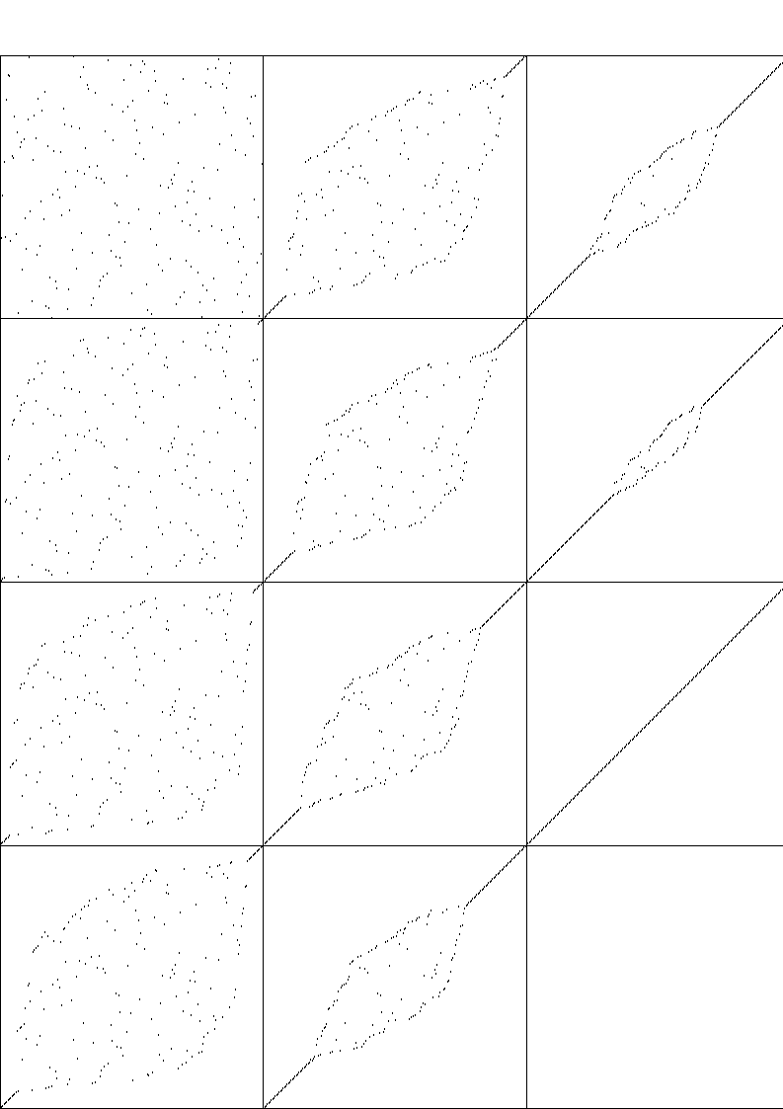 | 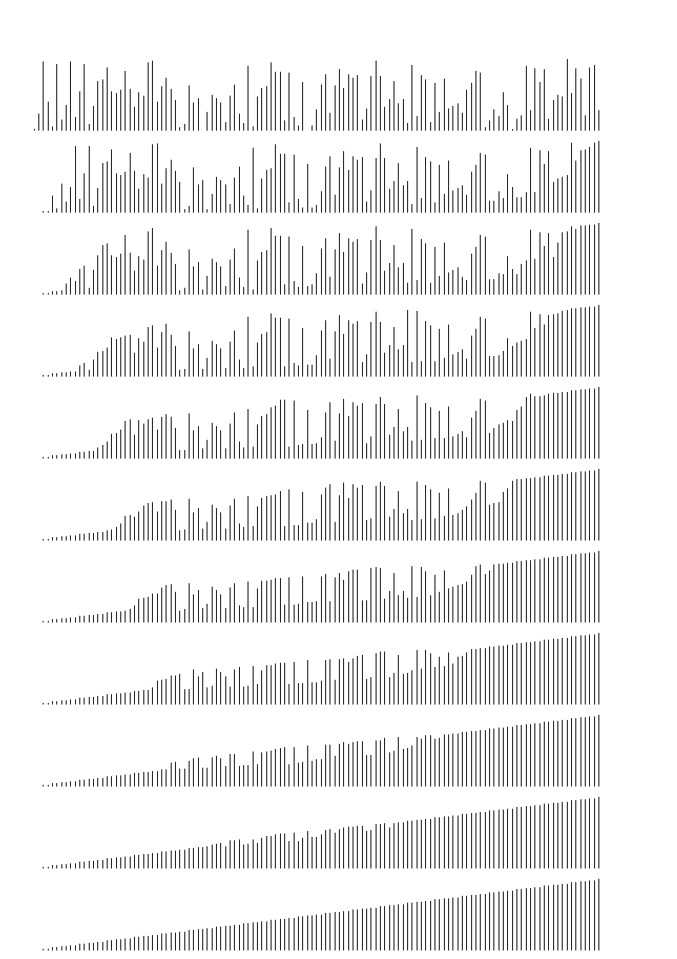

Exercises
- Implement the shaker sort algorithm as a generic function shaker_sort().
- Why is the number of swaps the same in bubble sort, adaptive bubble sort, and shaker sort?
- Run bubble sort and shaker sort on the same shuffled vector of size 1000. Count the number of inner loop comparisons in each case and give the percentage savings in using shaker sort.

Insertion Sort
Insertion sort is the sort of choice when the data are nearly sorted.

insertion_sort(vector& v)
for(right = 1; right < v.size(); right++)
for(i = right; i > 0 && v[i - 1] > v[i]; i--)
swap( v[i - 1], v[i] );

Insertion Sort  best for nearly  sorted data  semi-slow to run  stable  in-place | 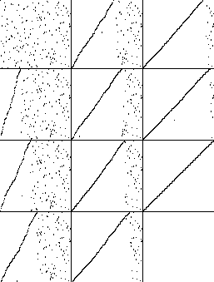 | 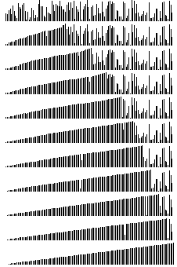

Exercises
- Implement the insertion sort algorithm as a generic function insertion_sort().
- Insertion sort moves successive elements into position, "walking them down" the previously sorted portion of the vector, by making several swaps. An improvement can be made by storing the element whose index is controlled by the outer loop, sliding elements to the right with v[i] = v[i – 1] rather than a swap, and then placing the stored element into its final position. Implement this improvement as insertion_sort1().
- Insertion sort performs a frequent test for an infrequent occurrence, namely insuring that the index within the inner loop never reaches zero. We can omit this test if we first do a pass through the vector to find the least element and then swap the least element into the initial position. Implement this improvement as insertion_sort2() and explain why it allows you to eliminate a comparison from insertion sort's inner loop.
- The quick implementation of the previous optimization loses the stability of insertion sort. Redo the implementation as insertion_sort3() in a slower but stable way.
- Suppose insertion sort operates on a vector whose elements are originally reverse-sorted. Give the "dot diagram" pictures taken when the outer for loop is 0%, 25%, 50% and 75% of the way done.

Heap Sort
Heap sort is an in-place guaranteed sort. It uses a heap, which is a binary tree in which the children never exceed their parents.

heap_sort(vector& v)
//Assume data to be sorted starts at v[1].
//Otherwise an initial pass can swap the minimum to v[0].

//Build a heap
for(index = (v.size() - 1) / 2; index >= 1; index--)
repair_heap(v, index, v.size() - 1 );

//Swap greatest element to end and repair the heap
for(last = v.size() - 1; last > 1; last--)
swap( v[1], v[last] );
repair_heap(v, 1, last - 1 );

repair_heap(vector& v, int bad, int last)
while(2 * bad <= last) //while bad index is a parent
big_child = 2 * bad;
if(big_child < last && v[big_child] < v[big_child + 1])
big_child++;
if(v[big_child] <= v[bad]) return;
swap(v[bad], v[big_child]);
bad = big_child;

Heap Sort  guaranteed  fast to run  not stable  in-place | 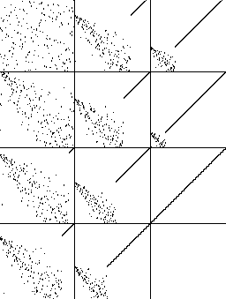 | 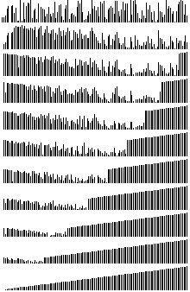

Exercises
- Implement the heap sort algorithm as a generic function heap_sort(). Include the "initial pass".
- What is the time complexity of repair_heap()? Explain.
- What is the time complexity of the entire heap-building part of the algorithm? Explain.
- What is the time complexity of the entire algorithm after the initial heap has been built? Explain.
- Carefully explain why heap sort has 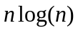 complexity.
- Where is the algorithm using short-circuit evaluation? What might go wrong if the order of those Boolean conditions were reversed?
Merge Sort
Merge sort is a stable sort.

merge_sort(vector& v, int first, int last)
if (first == last) return;
int mid = (first + last) / 2;
merge_sort (v, first, mid);
merge_sort (v, mid+1, last);
merge(v, first, mid, last);

//Assuming v[first]..v[mid] and v[mid+1]..v[last] are sorted…
merge(vector& v, int first, int mid, int last)
vector aux = v; //auxiliary storage
int left = first, right = mid + 1;
for(pos = first; pos <= last; pos++)
if(left > mid) v[pos] = aux[right++];
else if( right > last ) v[pos] = aux[left++];
else if( aux[left] <= aux[right] )
v[pos] = aux[left++];
else v[pos] = aux[right++];

Merge Sort  guaranteed fast  to run  stable  not in-place | 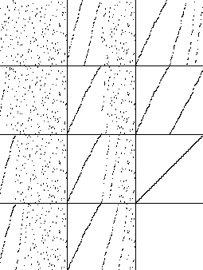 | 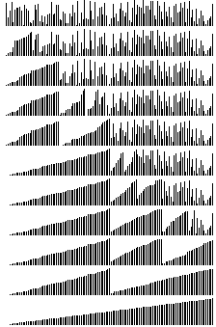

Exercises
- Implement the merge sort algorithm as a generic function merge_sort().
- Explain why merge_sort() is stable.
- Carefully explain why merge sort has complexity.
- A bitonic_merge_sort() uses a bitonic_merge() function whose auxiliary vector has the right half of the original data copied in reverse order. This allows us to eliminate two of the four inner-loop comparisons in merge(). Implement it.
- Explain why bitonic_merge can eliminate two inner-loop comparisons from a straightforward implementation of merge.
- Give a small (4 elements is sufficient) example showing that bitonic_merge_sort is not stable.
Quick Sort
In most cases, nothing outperforms quick sort, though its worst case could be n².

quick_sort(vector& v, int first, int last)
if(first >= last) return;
i = partition(v, first, last);
quick_sort(v, first, i-1);
quick_sort(v, i+1, last);

int partition(vector& v, int first, int last)
int left = first - 1;
int right = last;
while(true)
while(v[++left ] < v[last]);
while(v[--right] > v[last])
if(right == first) break;
if(left >= right) break;
swap(v[left],v[right]);
swap(v[left],v[last]);
return left;

Quick Sort  overall fastest  not stable  in-place  poor worst case | 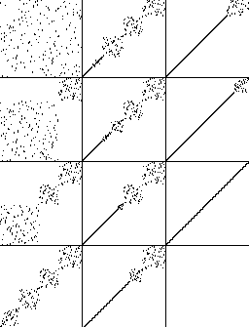 | 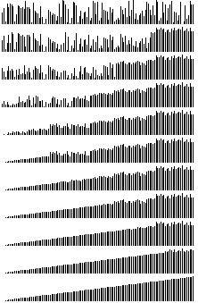

Exercises
- Implement the quick sort algorithm as a generic function quick_sort
- What happens in the worse case, when the data is already sorted?
- Implement the “median of 3” modification and explain why it might be an improvement: if the range has at least 3 elements, then use the median of the first, middle, and last elements as the pivot element.
- A recursive procedure will call itself for many small sub-cases, so an efficient method of dealing with the small cases is important. Implement having quick sort finish with insertion sort on any sub-vector of size less than M = 20.
- Referring to the previous exercise, experiment with values of M in the range from 5-20 and report the results. (Hint: Use global variables to count the overall number of comparisons and swaps.)

